2024 Mental Health Matters Month Digital Toolkit

Download graphics and inset videos
Find Spanish version here

Graphic | Caption
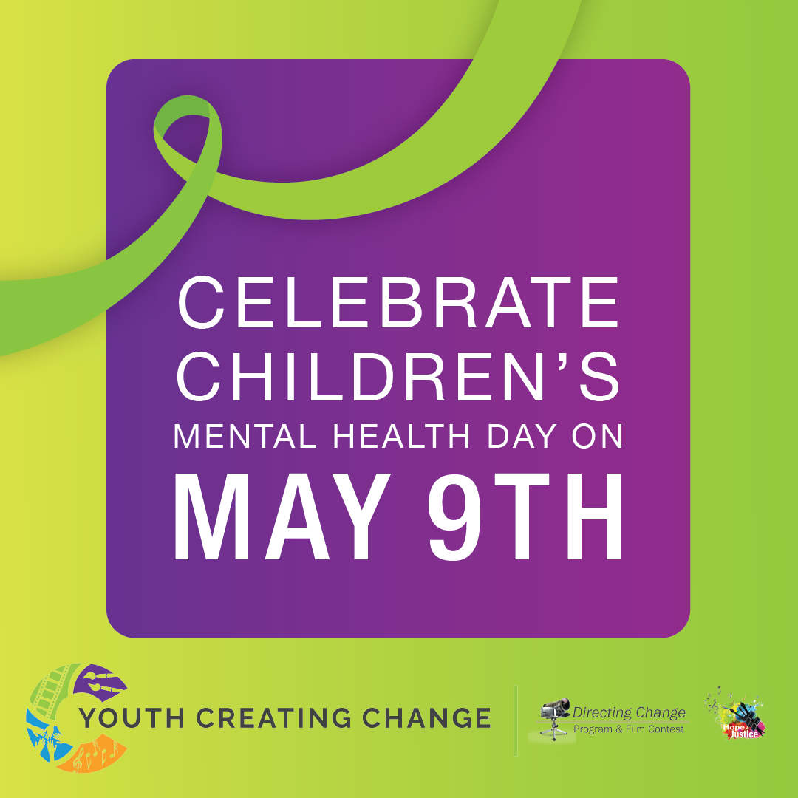  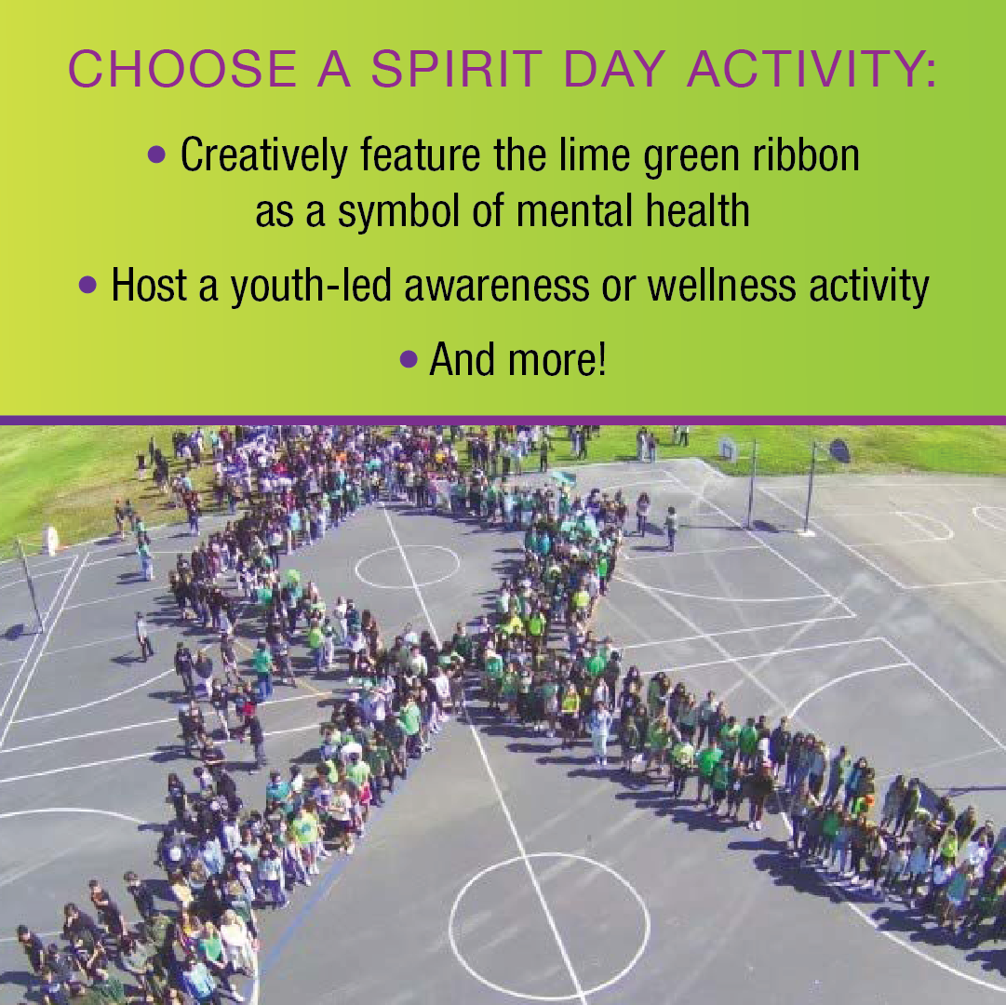  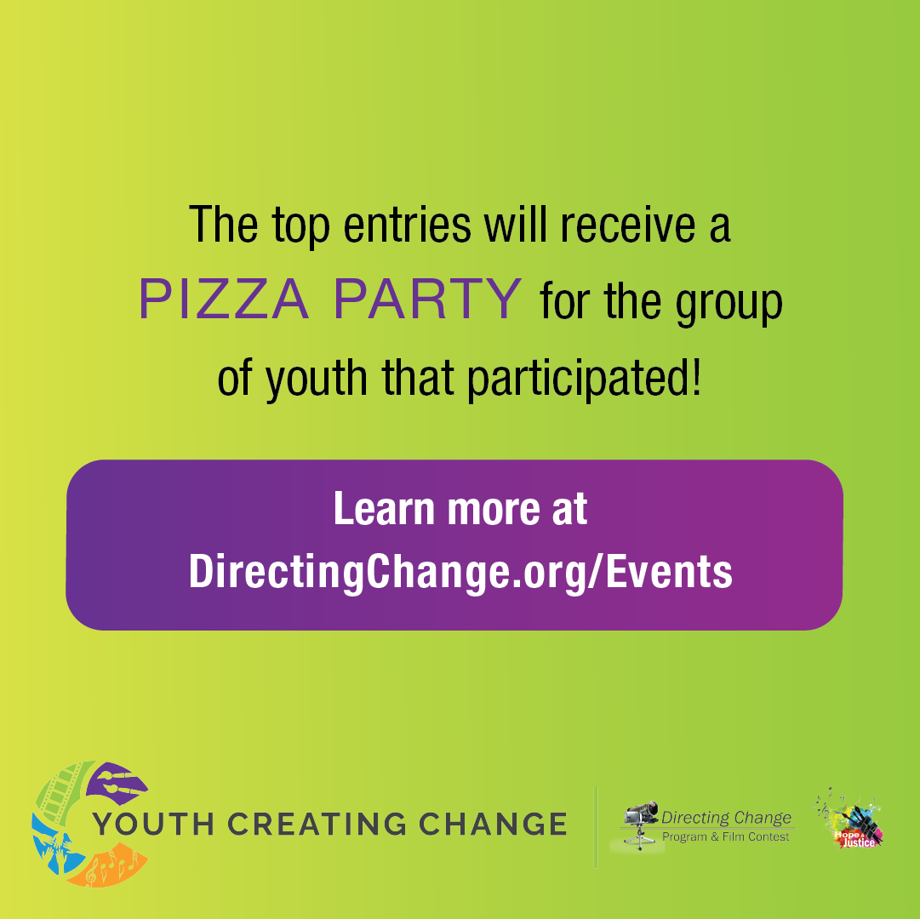 | May 9th, 2024 is Children’s Mental Health Day – a great time to engage youth in activities around mental health. Youth Creating Change is hosting their annual Mental Health Spirit Day and all youth, schools and orgs are invited to participate! Show your mental health spirit and submit proof of participation by midnight on May 13th and you could win a pizza party!  Learn more at DirectingChange.org/events  #mentalhealthmonth #mentalhealthmatters  Facebook: @DirectingChangeCA  Instagram: @DirectingChange  Twitter: @DirectChangeCA  Download graphics
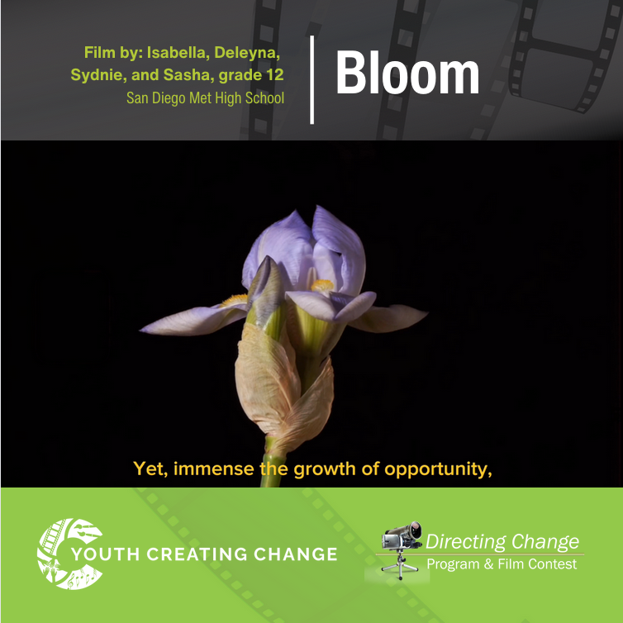  Download graphic and inset videos | Conversations about mental health can be hard, especially for those who come from immigrant families. By continuing to share stories like those of the youth filmmakers of “Bloom,” we can make it easier for others going through similar struggles to talk about their experiences.  The youth who created this film shared, “‘Bloom’ analyzes the guilt of talking about your mental health struggles when trying to be grateful for the better life your family fought for.”  “Bloom” was submitted to the Directing Change Film Contest, which asks youth to create 60-second films about mental health and suicide prevention.  Learn more at DirectingChange.org/events  Watch the film here: vimeo.com/919733913  Facebook: @DirectingChangeCA  Instagram: @DirectingChange  Twitter: @DirectChangeCA
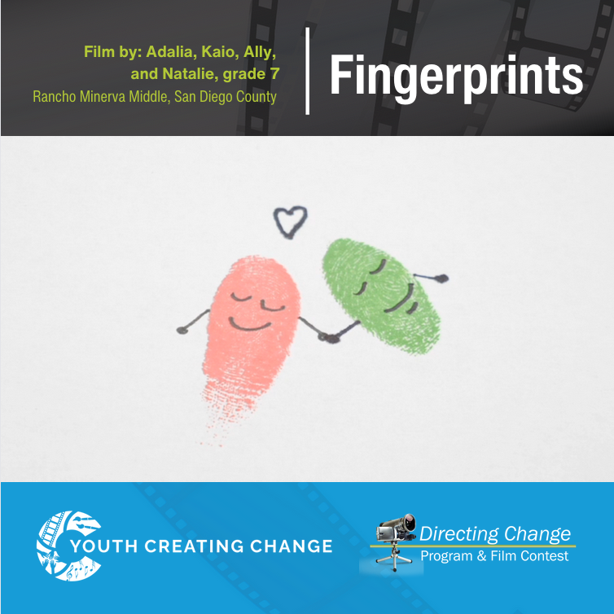  Download graphic and inset videos | Sometimes we hide our emotions from others, but we all deserve the opportunity to talk openly about our mental health. Checking in with others shows that they can open up as well.  “Fingerprints” was submitted to the Directing Change Film Contest, which asks youth to create 60-second films about mental health and suicide prevention.  Learn more at DirectingChange.org/events  Watch the film here: vimeo.com/683588834  Facebook: @DirectingChangeCA  Instagram: @DirectingChange  Twitter: @DirectChangeCA
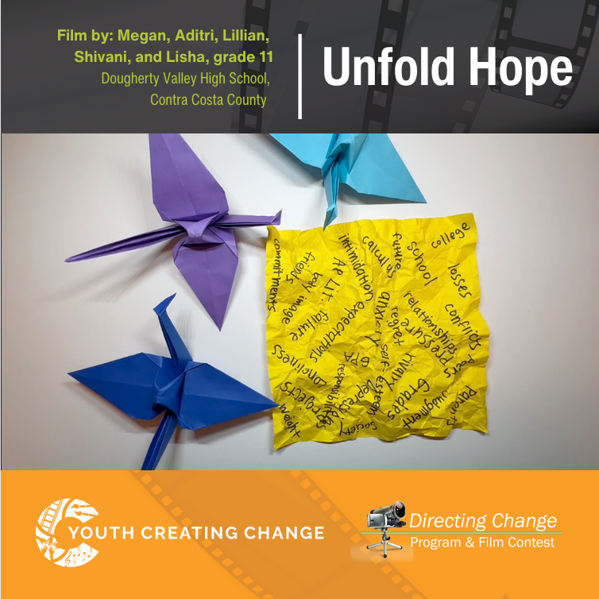  Download graphic and inset videos | Often, youth experiencing mental health challenges can feel alone in their struggles. By using resources and talking more openly about mental health, youth can find communities of other young people who they can relate to.  The youth who created “Unfold Hope” shared, “I learned that I don't need to hide what I am going through, that it's okay to talk about it, and also take time to take care of my mental health.”  “Unfold Hope” was submitted to the Directing Change Film Contest, which asks youth to create 60-second films about mental health and suicide prevention.  Learn more at DirectingChange.org/events  Watch the film here: vimeo.com/917319446  Facebook: @DirectingChangeCA  Instagram: @DirectingChange  Twitter: @DirectChangeCA
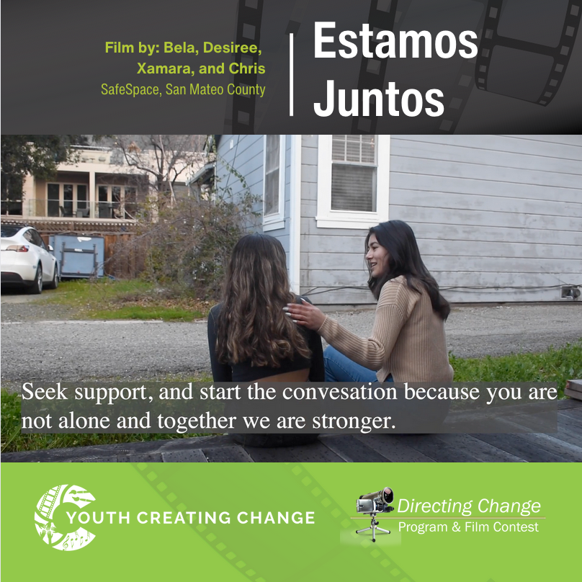  Download graphic and inset videos | The way we talk about mental health and seek help can be influenced by our culture. It’s important to start conversations between different generations to reduce stigma and find support.  “Estamos Juntos” was submitted to the Directing Change Film Contest, which asks youth to create 60-second films about mental health and suicide prevention.  Learn more at DirectingChange.org/events  Watch the film here: vimeo.com/803353784  Facebook: @DirectingChangeCA  Instagram: @DirectingChange  Twitter: @DirectChangeCA
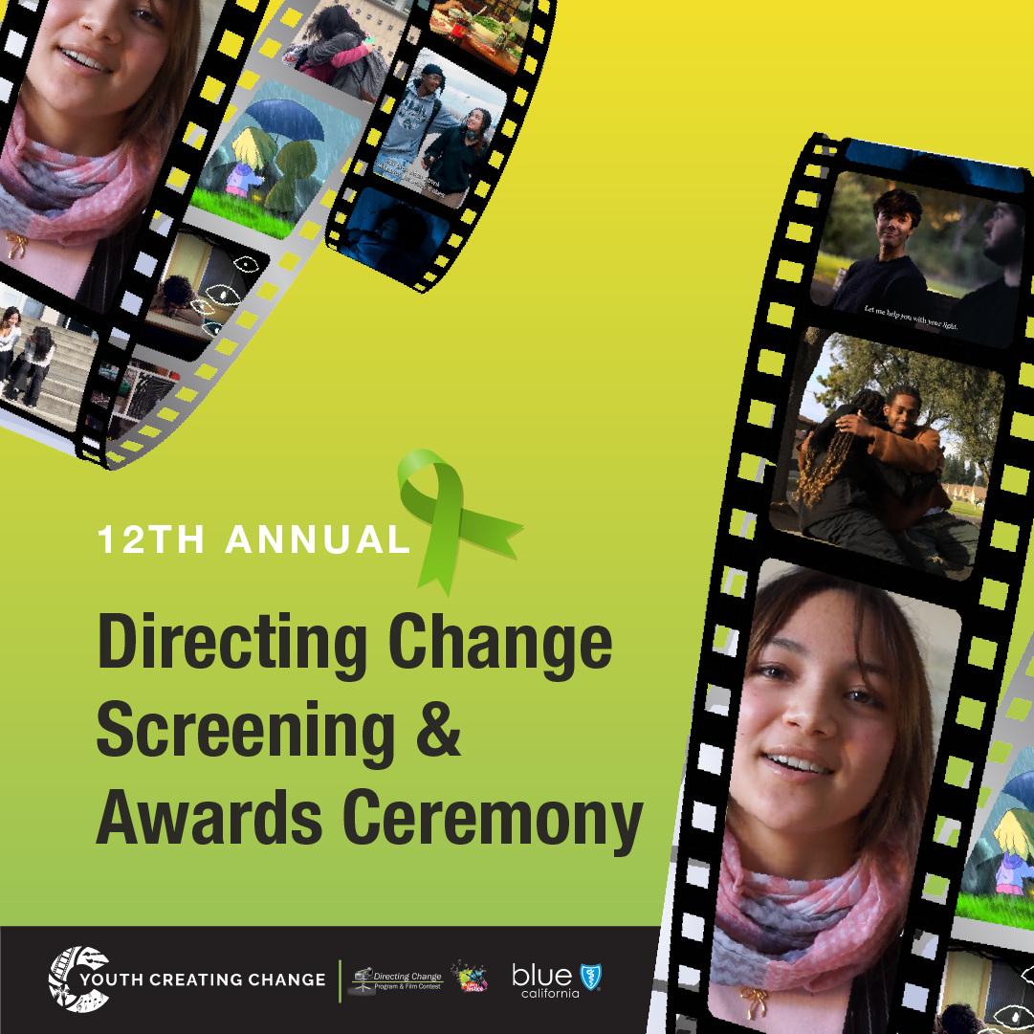  Download graphic | You’re invited! Join Youth Creating Change on May 21st for the 12th Annual Directing Change Screening & Awards Ceremony. The red carpet event will celebrate youth from across California who created films about mental health and suicide prevention.  Reserve your free ticket: 2024directingchangeawardceremony.eventbrite.com  Facebook: @DirectingChangeCA  Instagram: @DirectingChange  Twitter: @DirectChangeCA
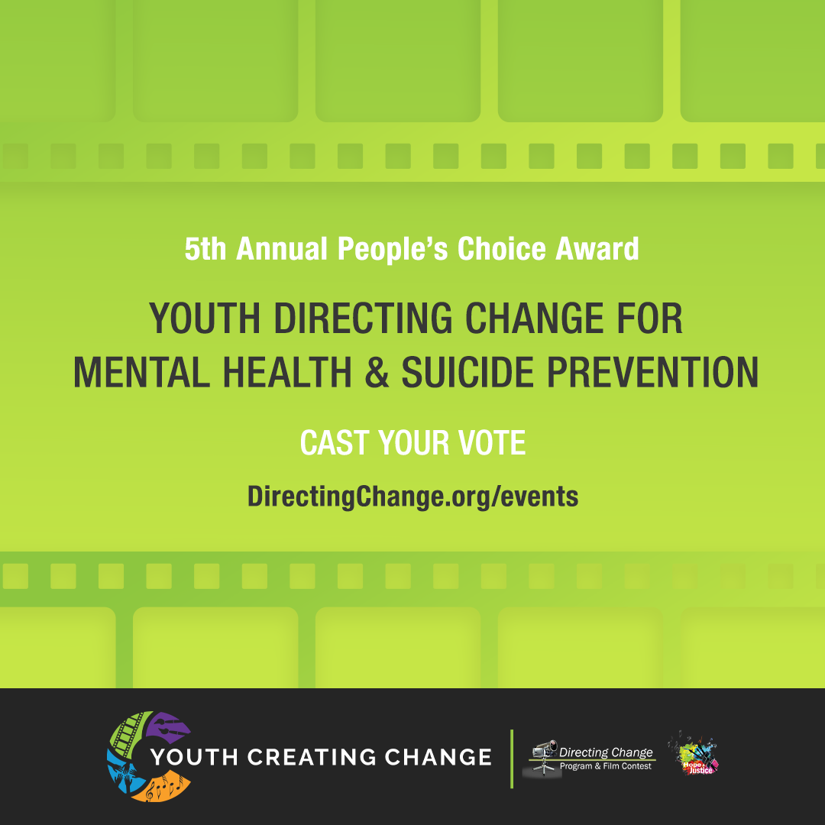  Download graphic | Celebrate youth voices and creativity by voting for your favorite mental health and suicide prevention PSA created by youth across California as part of the 12th annual Directing Change Film Contest.  Vote at DirectingChange.org/events  Facebook: @DirectingChangeCA  Instagram: @DirectingChange  Twitter: @DirectChangeCA
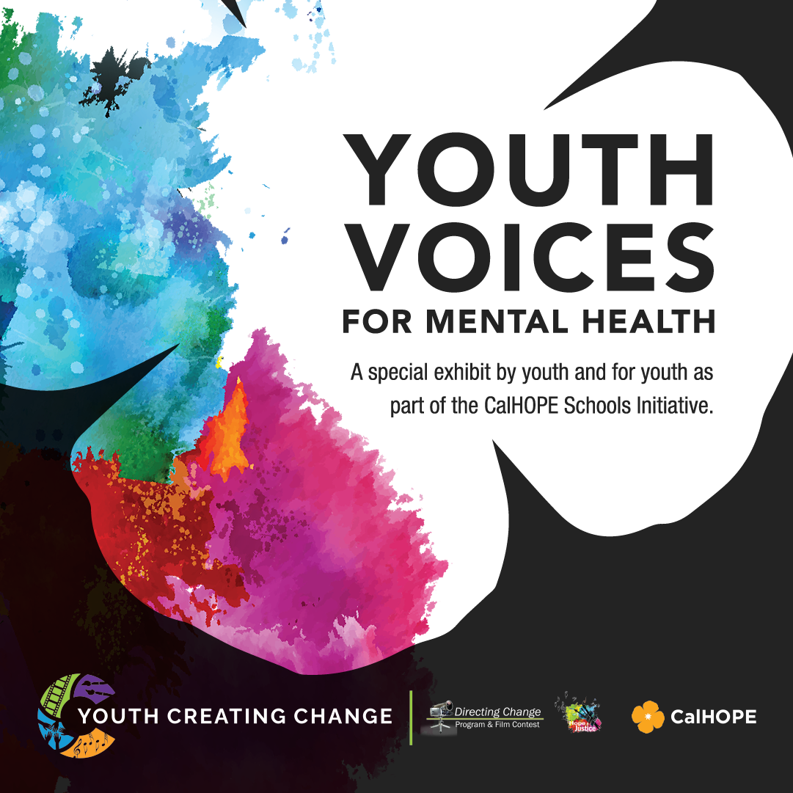  Download graphic | Youth Voices for Mental Health is a collection of art, short films, and narratives received by young people across California as part of the Hope & Justice Contest in partnership with the CalHOPE Schools Initiative. Funded as part of the Children and Youth Behavioral Health Initiative (CYBHI), The CalHOPE Schools Initiative offers no-cost resources for students and schools to support relationships, build resilience, and provide inspiration and support for students, educators and families.  View the exhibit here: gallery.directingchange.org/virtual-art-exhibit
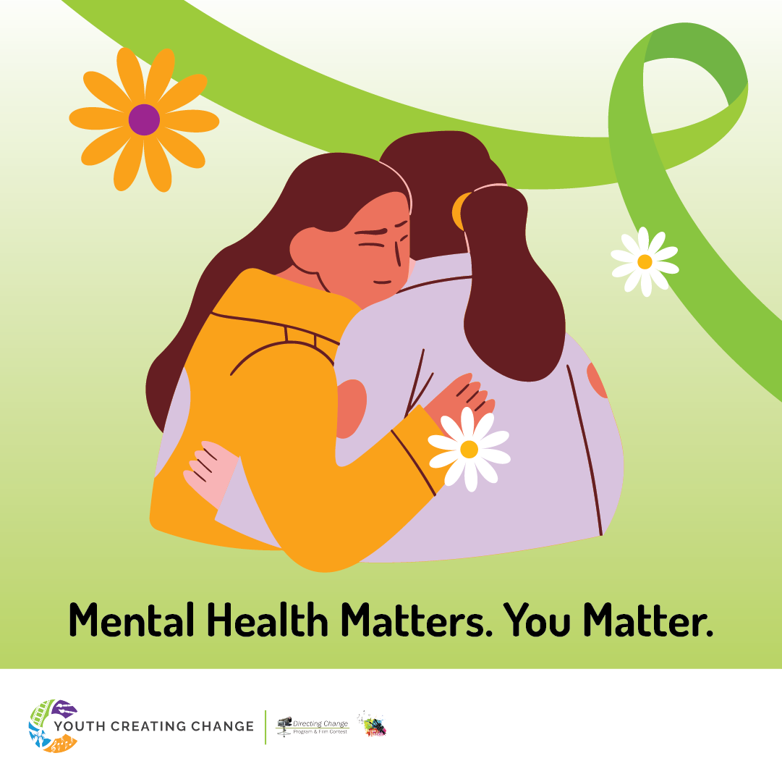  Download graphic | May is Mental Health Matters Month and a great time to take action for mental health. Check in with a friend and learn about mental health resources available in your community.  Learn about events celebrating young people’s mental health at DirectingChange.org/events.  Looking for mental health support? Soluna is an app for teens that offers safe space to explore and manage your well-being through resources, forums, and more. It's free, easy to use, and confidential. Learn more at CalHope.org  Facebook: @DirectingChangeCA  Instagram: @DirectingChange  Twitter: @DirectChangeCA
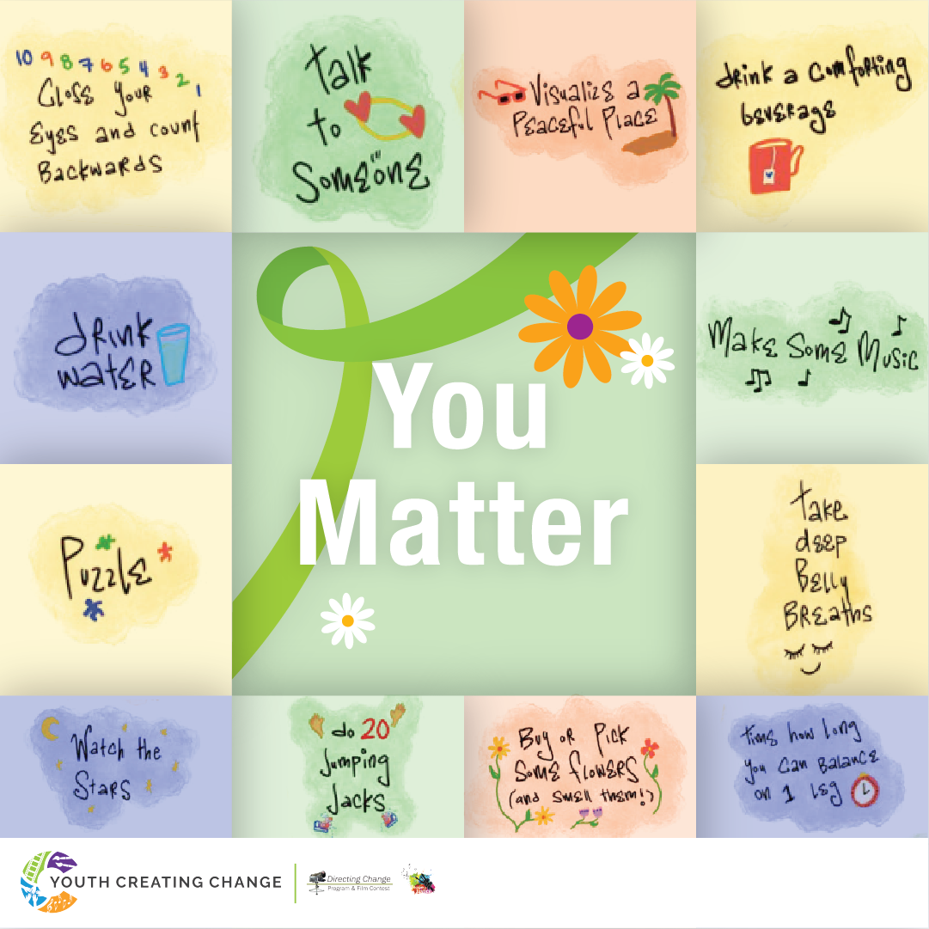  Download graphic | Tough times are part of life. Coping is how we draw on the inner strength and resilience that allows us to keep going, protecting us when we might feel like giving up. Remember: self-care helps us check-in with ourselves, recharge, and helps us be the best version of ourselves we can be! Your feelings matter!  Download a Mental Health Thrival Kit and learn about events celebrating young people’s mental health at DirectingChange.org/events  Facebook: @DirectingChangeCA  Instagram: @DirectingChange  Twitter: @DirectChangeCA
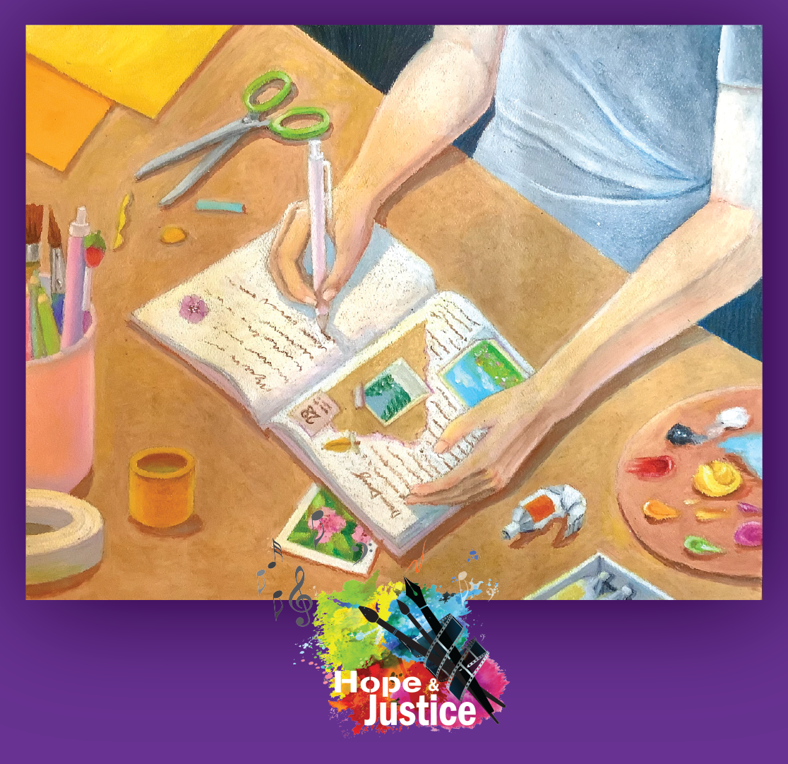 | “Journal of Hope” was submitted to the Youth Creating Change Hope & Justice Art & Film Contest, which asks youth to express how they cope with tough times.  The youth who created “Journal of Hope” shared, “After journaling for a few years, I realized that it was a great way for people to get through difficult times and maintain good mental health. It helps in processing thoughts and identifying your problems. Oftentimes, letting your feelings out on paper can alleviate many of the burdens weighing down on you.”  Download journaling prompts at DirectingChange.org/events  Facebook: @DirectingChangeCA  Instagram: @DirectingChange  Twitter: @DirectChangeCA
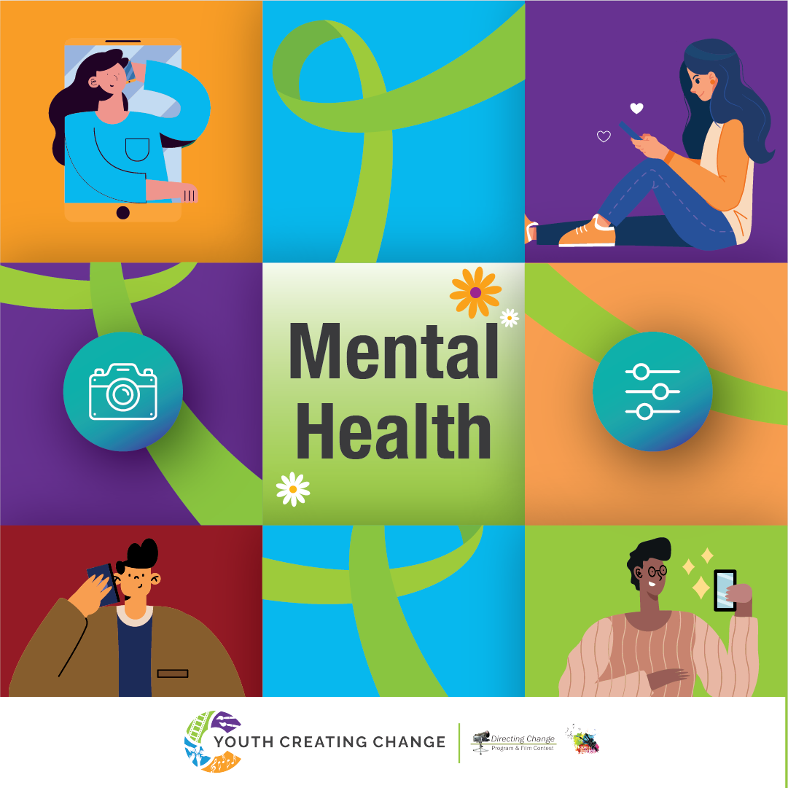  Download graphic | In celebration of Mental Health Matters Month, May’s Hope & Justice monthly prompt “Snap, Filter & Swipe” asks youth to think about the impact of social media on our mental health. Incorporate the lime green ribbon as a symbol for mental health awareness and take part in one of our special TikTok or Photo/Digital Art Challenges for a chance to win up to $300 in prizes!  Visit DirectingChange.org/events to get started.  #DirectingChange #artcontest #mentalhealth #MayisMentalHealthMattersMonth #TikTokChallenge #PhotoContest #MentalHealthMattersMonth #socialmedia #filter

