2021 Selection of Walk in Our Shoes PSAs (60-second films)

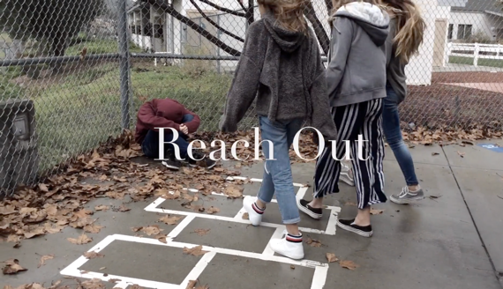
The Superhero in Each of Us (Suicide Prevention)

How to Help a Friend (2019)
San Diego County, San Pasqual Union School
This film follows a group of friends as they discover a classmate’s struggles and reach out to a trusted adult at school.
https://vimeo.com/320845830

The Music in Me (2021)
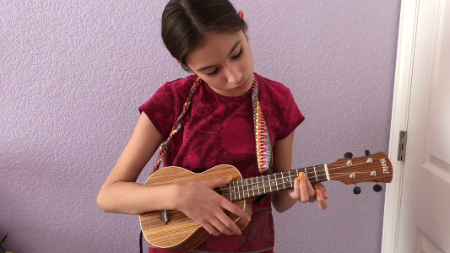
Tri-City (Los Angeles County), Mountain View Elementary School
A girl begins to lose interest in what she loves doing, but with her sister’s support, she starts to feel better and play music again. “We wanted to portray the message that whatever you’re going through, you’re not alone, there’s always hope.” https://vimeo.com/519742721
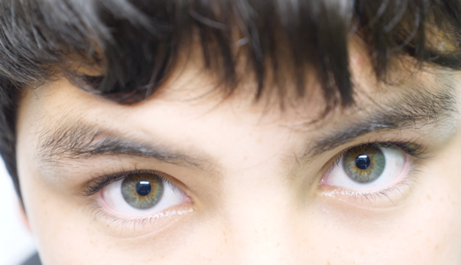

Windows (2020)
San Diego County, Rancho Minerva Middle School
Close up views of student's eyes are shown to symbolize windows to the soul, communicating the message that you deserve to be seen and to be happy.
https://vimeo.com/378382450

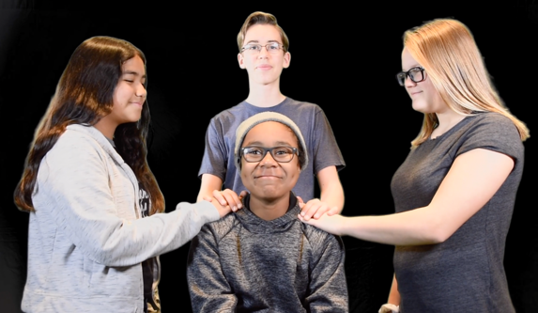
Keep an Eye on Me (2019)
Riverside County, David A Brown Middle School
A student describes his struggles with depression and loneliness and expresses how his friends give him hope. https://vimeo.com/320885053
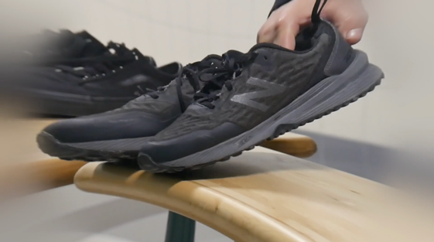

Sympathetic Steps (2020)
San Diego County, Hawking STEAM Charter School 2
A boy walks in the shoes of several other boys and sees their life struggles from their perspective.
https://vimeo.com/394111258
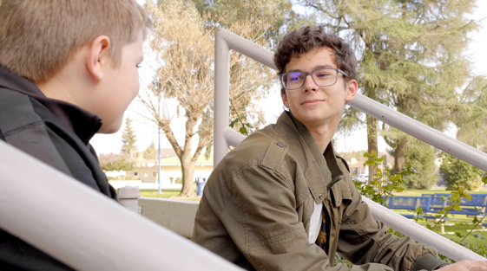
Helping a Hero (2019)
Fresno County, Rafer Johnson Jr. High Kingsburg
A superhero loses his powers, but a friend reaches out to let him know he cares.
https://vimeo.com/320651212

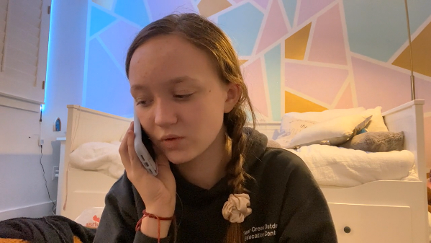
Help Equals Hope (2021)
Los Angeles County, Palms Middle School Modern Media and Communications Magnet
A girl’s friend connects her to suicide crisis line after noticing changes in her behavior. “I feel it is crucial for people to give a helping hand to a person who is experiencing symptoms of depression.”
View film - https://vimeo.com/517646947

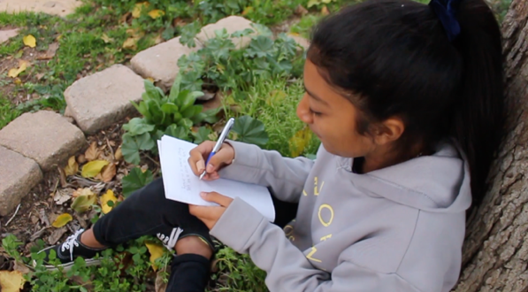
What is Mental Health?

AnxIety (2019)
San Diego County, Mission Middle School
A student deals with anxiety and talks about what methods help her cope with it.
https://vimeo.com/320996082
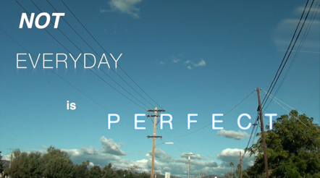
Feeding My Heart (2019)
San Diego County, Mission Middle School
A student explains the importance of taking care of your mental health along with your physical health.
https://vimeo.com/320996791

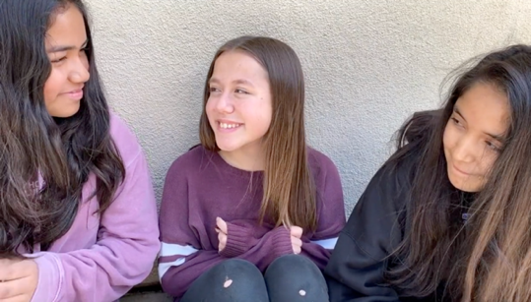
Make Your Mark (2020)
Riverside County, David A Brown Middle School
A girl hides her true feelings behind a smile and laughter until she finds friends that like her for who she is. She finds power and strength in expressing and being her real self.
https://vimeo.com/394590163

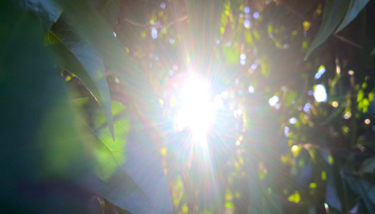
Healing (2019)
Los Angeles County, Hale Charter Academy
A student struggles with depression and learns to see the light in the darkness and that her depression does not define her.
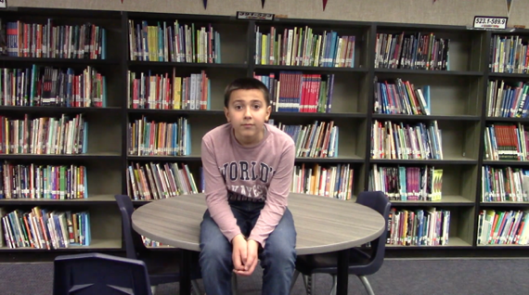
https://vimeo.com/330155201

My Life (2020)
Riverside County, Mountain View Middle School
A boy is diagnosed with ADHD, feels alone and is struggling in school until he reaches out for help and starts to see the light.
https://vimeo.com/392282373
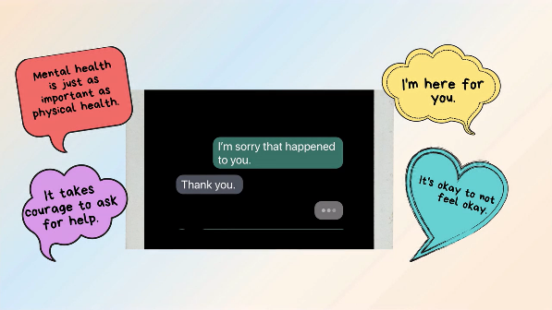
I’m Here For You (2021)
Los Angeles County, Bret Harte Preparatory Middle School
A text message exchange showing how you can be a supportive friend to someone going through a difficult time. “I’m here to listen and won’t judge you.”
https://vimeo.com/518279454

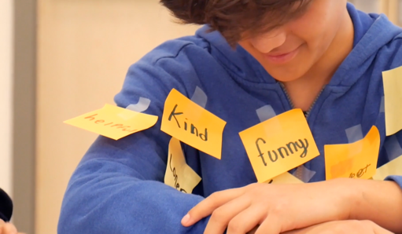

Words Matter

Invisible (2020)
San Diego County, Hawking STEAM Charter School 2
A student struggles as he's being labeled and bullied at school. A friend reaches out to him and uses positive words to build him up. https://vimeo.com/394496406
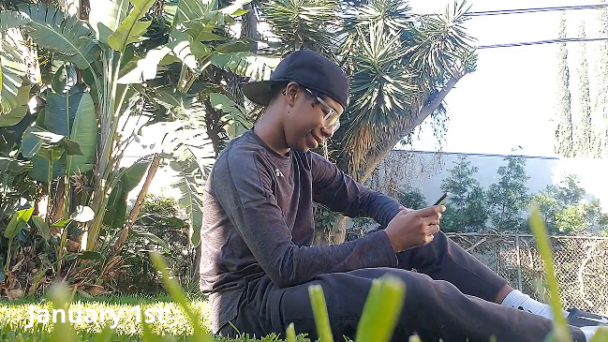
Online Dangers: The Power of Our Words (2021)
Los Angeles County, Palms Middle School Modern Media and Communications Magnet
A boy dealing with cyberbullying receives a kind message from a friend. “It might be easy to ruin someone’s day... it’s just as easy to make someone’s day.” https://vimeo.com/517647734

The Effect of Words (2020)
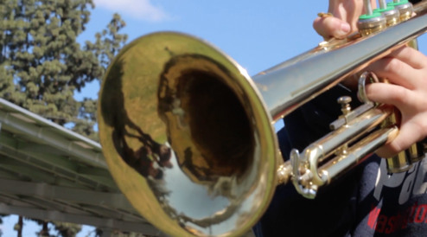
Tulare County, Washington Elementary
A boy expresses the difficulties of struggling with mental health issues and how they can not be turned on and off like a light switch. Sometimes all a person needs is support and understanding. https://vimeo.com/395106344

