2021 Selection of Suicide Prevention PSAs (60-seconds)
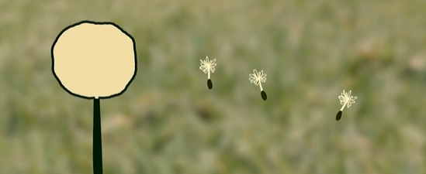
Dandelion (2021)
Los Angeles County, Hilda Solis Learning Academy
This mixed media film shows that if you reach out when you’re struggling, someone will be there to listen. The narrator is persistent to get help because she knows that her life is important.
View & Download
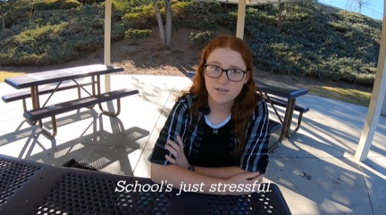
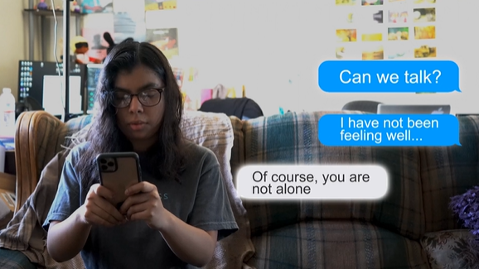
I Am Not Alone (2021)
Tri-City (Los Angeles County), California Polytechnic University, Pomona
A girl who is struggling reaches out for help and gets the support that she needs. The film reminds viewers that they never have to deal with suicidal thoughts alone.
View & Download
The Promise (2021)
Riverside County, Murrieta Valley High School
A film that shows how to empathetically start the conversation with a friend who has changes in their behavior and connect them to the National Suicide Prevention Lifeline.
View & Download
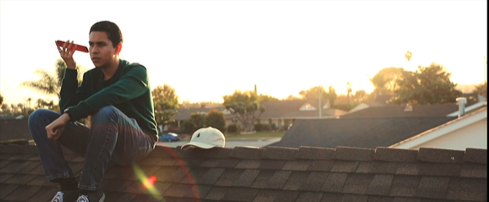
An Awkward Conversation (2020)
Orange County, Valencia High School
In a voicemail, a boy shares his concerns to a friend and asks him directly if he is thinking of suicide, so the friend decides to reach out to a crisis line for help.
View & Download
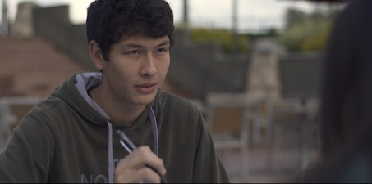
By Your Side (2020)
San Diego County, Rancho Bernardo High School
A boy notices his friend is showing some of the warning signs of suicide, so he starts a conversation with her. He says it isn’t her fault and can’t stand by and watch her go through this alone.
View & Download
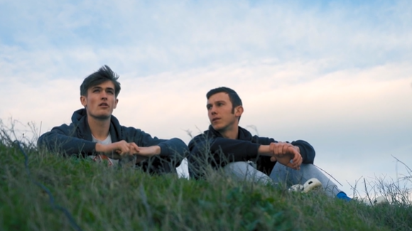
Reach Out (2020)
San Mateo County, Burlingame High School
A boy has trouble concentrating while hanging out with his friend, distracted by the stress of daily life. His friend notices and asks him directly if he’s thinking of suicide.
View & Download

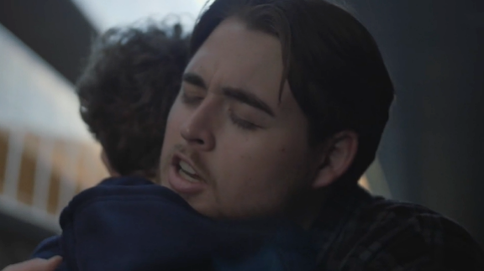
I Love You So Much It Hurts (2019)
Orange County, Orange Coast College
A powerful film that shares the thoughts someone has about their friend who is thinking of suicide, which show how much they deeply care for the friend.
View & Download
Summit (2019)
Butte County, Pleasant Valley High School
A boy leaves a message for his friend asking if he’s thinking of suicide. The film talks about the beauty and hope that the future holds, despite difficult times.
View & Download
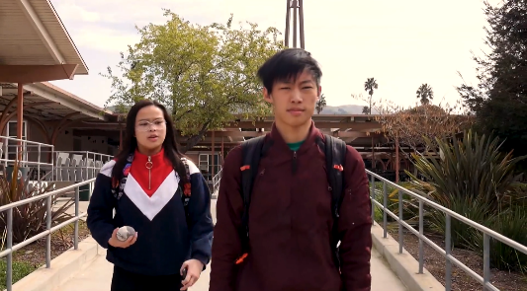
Direct Message (2019)
Riverside County, Encore High School
A film about how it’s okay to break a friend’s trust to get them help. A girl texts her friend that she’s thinking of suicide and another friend tells her how to reach out to the Crisis Text Line.
View & Download
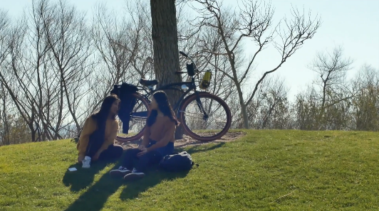
Reaching Out (2019)
Alameda County, Mission San Jose High School
A girl is aware of the subtle changes in her friend and how they may be warning signs of suicide. She asks him the question directly and she connects him to help.
View & Download
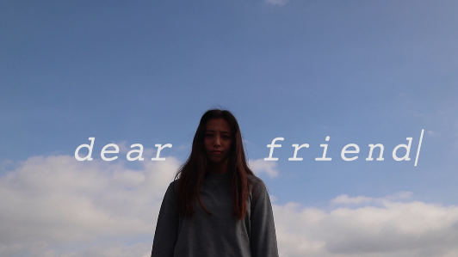
A Journey You Don’t Fight Alone (2019)
Riverside County, Eleanor Roosevelt High School
A spoken word from a girl to her friend, talking about the pain she sees her friend in and offering her comfort and support.
View & Download
Dear Friend (2018)
Orange County, Foothill High School
A compassionate letter to a girl from her friends asking if she’s been thinking of suicide and telling her how they will be there to get her the help she needs.
View & Download

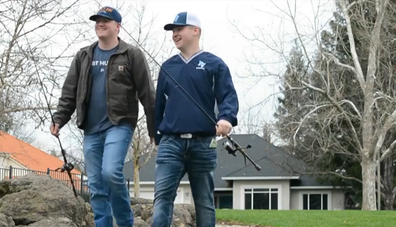
All That Matters (2017)
Butte County, Pleasant Valley High School
An inspiring story about the special bond between two brothers and how recognizing the warning signs and reaching out to help a loved one in distress can save a life.
View & Download
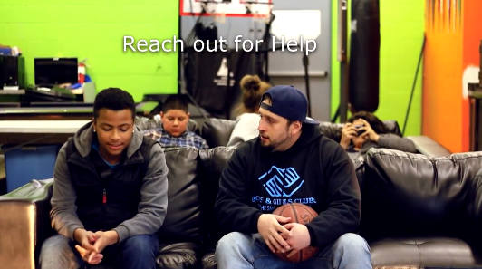
Speak Out (2017)
Riverside County, Boys & Girls Club San Gorgonio Pass
Friends notice the warning signs for suicide in a friend and seek the advice of their basketball coach, a trusted adult who reaches out and follows up with their friend.
View & Download
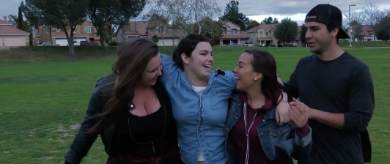
The Empty Seat (2017)
Riverside County, Murrieta Valley High School
Friends recognize warnings signs in a friend and reach out to support her. Together, they connect her to help.
View & Download
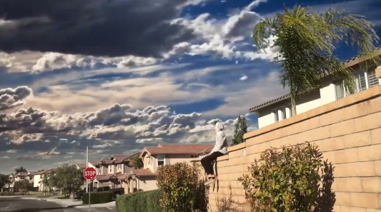
This Isn’t the End (2017)
Placer County, Whitney High School
A girl who experienced thoughts of suicide reflects on how her friends noticed the signs and reached out to help her when she needed them most.
View & Download
Leap of Faith (2016)
Riverside County, Murrieta Valley High School
A story of two best friends and how one notices the warning signs for suicide, confronts him directly, and reaches out to connect him to help.
View & Download
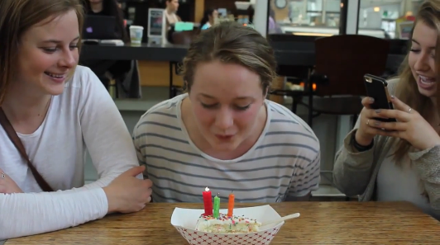
This is Claire (2016)
Yolo County, UC Davis
A film about a female college student who begins experiencing depression and finds a support system at her college campus Active Minds chapter.
View & Download

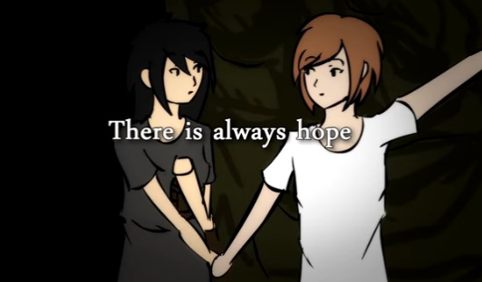
The Signs (2015)
Orange County, Canyon High School
A film focused on educating about the warning signs for suicide using an easy to remember metaphor of a car and traffic signs.
View & Download
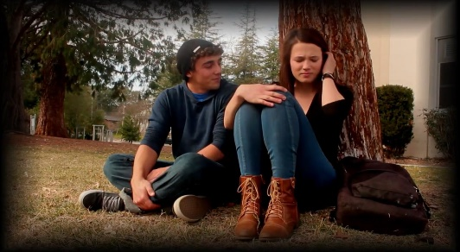
There is Always Hope (2015)
Sacramento County, Franklin High School
An animated film about two girls, which illustrates the warning signs for suicide and the importance of reaching out to an adult if you’re worried that someone is thinking about suicide.
View & Download
A New Tomorrow (2014)
Sonoma County, Analy High School
When one friend begins showing warning signs for suicide, a friend notices and seeks the help of a school counselor.
View & Download
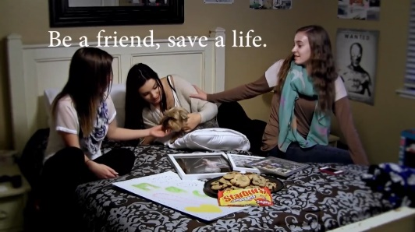
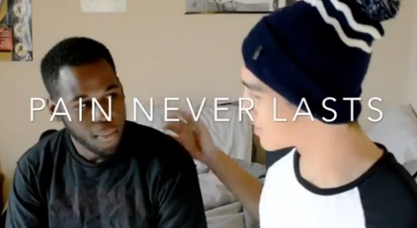
Never Underestimate the Power of Friendship (2014)
Placer County, Whitney High School
A young girl feels alone and is in crisis, when her three friends notice the signs, they quickly drive to her house and come together to support her.
View & Download
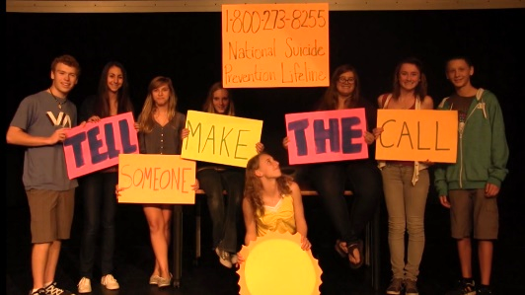
Pain Never Lasts (2014)
Riverside County, UC Riverside
A spoken word/poetry film about the struggles young men face, narrated by an African American male who reminds young people that pain never lasts and to hold on.
View & Download
Tell Someone (2013)
San Diego County, Del Norte High School
A story told in a poem and filmed on stage shows a girl who experiences thoughts of suicide. Her friends and family notice warning signs and reach out to her and call the National Suicide Prevention Lifeline for help.
View & Download

