2021 Selection of Suicide Prevention PSAs (60-seconds)
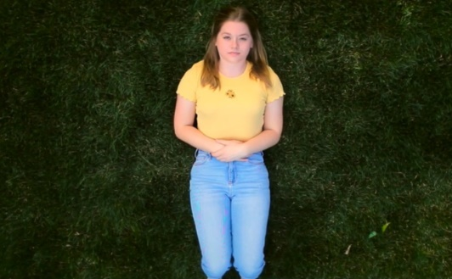
Another Light (2021)
Los Angeles County, Hilda Solis Learning Academy
An inspiring film about two girls who reach out to people they trust, including a parent and a teacher, who give them the resources and support they need.
View & Download
Bloom (2021)
Orange County, Portola High School
In this film, a garden represents a girl’s mental health. In the beginning, her garden suffers, but with the help of her loved ones, she recovers and grows.
View & Download
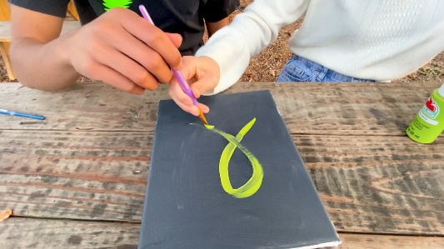
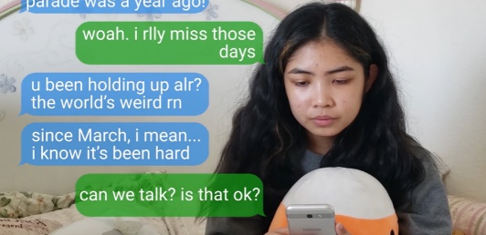
Courage (2021)
Sacramento County, Franklin High School
A girl feels nervous to reach out, but a friend texts her to check in on her wellbeing, which gives her the courage to talk openly and get support.
View & Download
A Stroke of Hope (2020)
Alameda County, Irvington High School
A boy decides to accept help and finds hope in his connection with others, who bring color back into his life.
View & Download
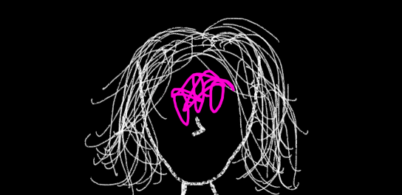
Abbreviated Soliloquies (2020)
Los Angeles County, Ghetto Film School
A spoken word about a girl's diagnosis with ADHD and social anxiety. She talks about both good and difficult days and how she finds hope.
View & Download
The Beauty of Mental Health (2020)
San Mateo County, Hillsdale High School
A film talking about using people-first language, speaking up about mental health, and reducing stigma.
View & Download

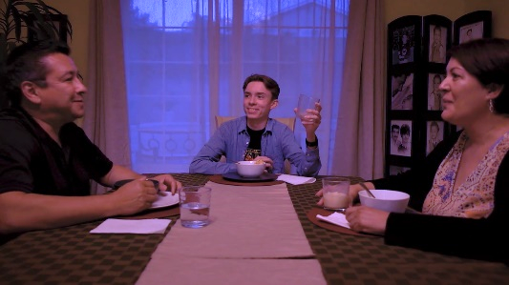
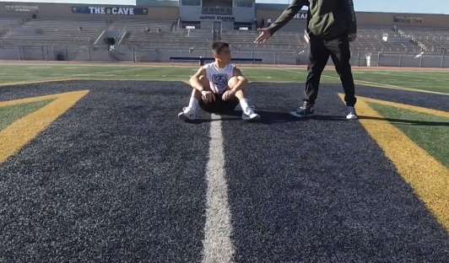
Conflicting Currents (2020)
San Bernardino County, Upland High School
A boy first refuses to accept help for his depression, but after sharing a resource with someone else who is struggling, he decides to reach out for help for himself.
View & Download
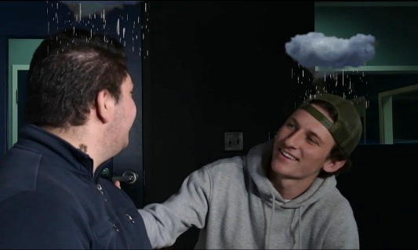
Hashiru (2020)
Los Angeles County, Warren High School
A boy loses interest in his favorite activity, running. He notices the changes in himself and decides to get help.
View & Download
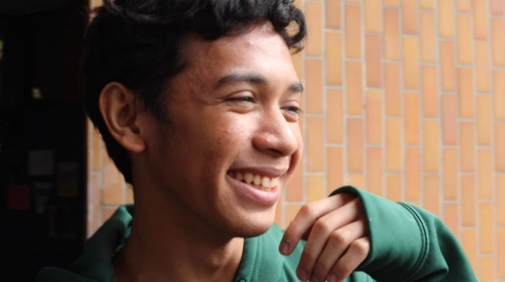
Rainy Days (2019)
Butte County, Pleasant Valley High School
A film that shows those struggling with their mental health are not alone. A boy sees that he is not the only one experiencing “rainy days” and finds a supportive group that understands him.
View & Download
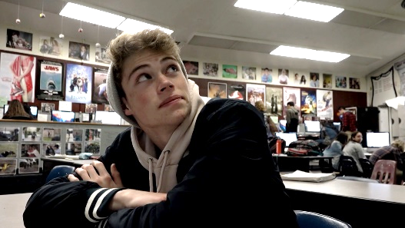
I AM (2019)
Los Angeles County, Los Angeles High School
A girl is aware of the subtle changes in her friend and how they may be warning signs of suicide. She asks him the question directly and she connects him to help.
View & Download
Speak Up (2019)
Tri-City (Los Angeles County), Claremont High School
A film about the importance of taking mental health as seriously as physical health. When someone checks in on him, a boy first says he’s okay, but then decides to speak up.
View & Download
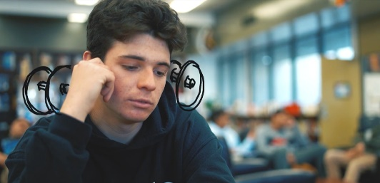
The Weight (2019)
Orange County, Canyon High School
A boy with depression normalizes his experience and encourages youth to lift “the weight” from their shoulders by getting help. He also recommends being aware of the signs of depression in others.
View & Download

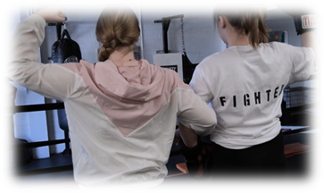
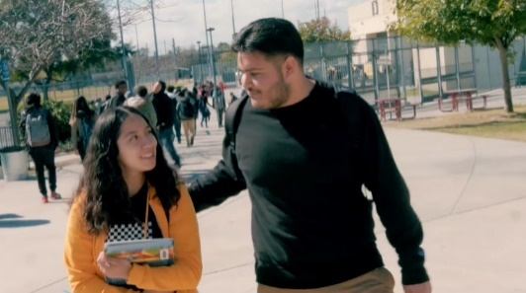
A Fighting Chance (2018)
Los Angeles County, The School of Arts and Enterprise
A window into a girl’s mind as she fights the symptoms of mental illness. The film reminds youth that they are not alone, and that people are there to listen and help them.
View & Download
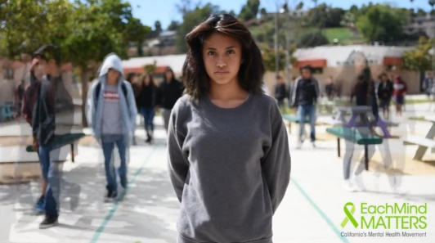
Behind the Smile (2018)
Los Angeles County, Santee Education Complex
A film about how to support a friend with depression by noticing changes in their behavior, being open minded, and listening. The film also encourages conversations about mental illness to break down stigma.
View & Download
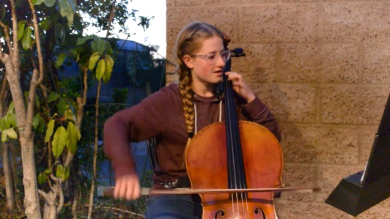
Esperanza en Nuestra Corazon (2018)
San Diego County, Rancho Minerva Middle School
A girl looks back on how she felt when she started experiencing symptoms of mental illness. The film reminds youth that there is help, treatment, and support available.
View & Download
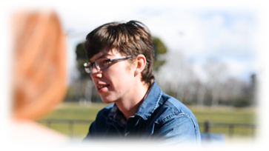
Hear the Music (2018)
Orange County, Canyon High School
A girl living with depression worries about how her family will react but decides to talk openly with them and they stay by her side. She compares her depression to music, with ups and downs.
View & Download
I Am Not Ashamed (2018)
Butte County, Pleasant Valley High School
A boy speaks openly about the symptoms of his mental illness and takes pride in his strength and his courage to seek help.
View & Download
Scribbled (2018)
Riverside County, Encore High School
A boy with depression learns he’s not the only one struggling, so he shares his story to make others feel less alone.
View & Download

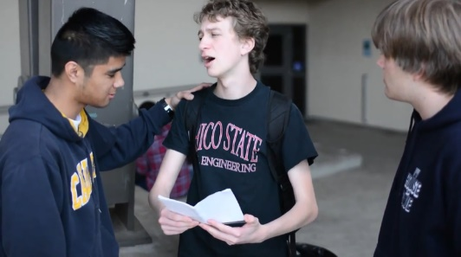
Off the Script (2016)
Butte County, Pleasant Valley High School
A film metaphorical film that reminds youth to not hide how they are feeling, to steer away from their same old script, and to instead talk openly and honestly about their mental health.
View & Download
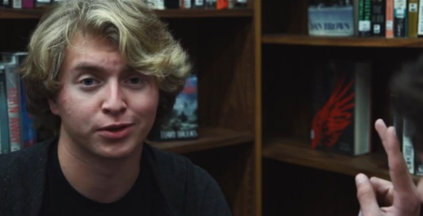
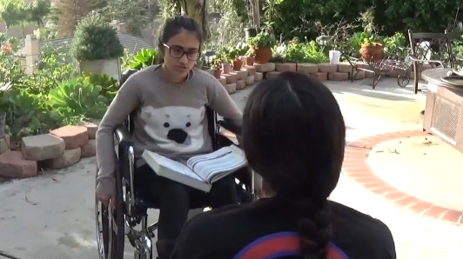
Instinct (2017)
Orange County, Canyon High School
A film that encourages youth to reach out to a friend experiencing a mental health challenge. The film highlights the fact that people often wait years to get help, but that 70-90% of people report improved quality of life after treatment, so feeling better is possible.
View & Download
Rising Up (2017)
Sacramento County, Franklin High School
An animated film with a hopeful message about facing the challenges of mental illness with the help of friendship.
View Film
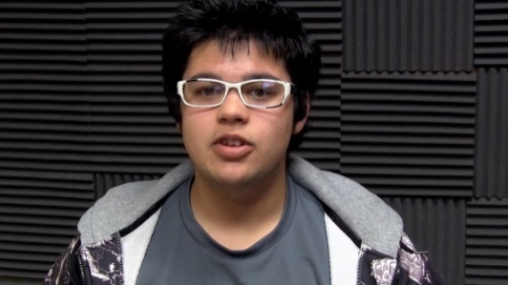
Real Life Super Hero (2016)
Del Norte County, Redwood Voice
This inspiring film teaches youth that anyone can be a superhero by supporting a friend experiencing a mental health challenge.
View & Download
Naivete (2016)
Sonoma County, Analy High School
This clever film discusses societal stigmas associated with mental illness and why no one should be treated differently.
View & Download
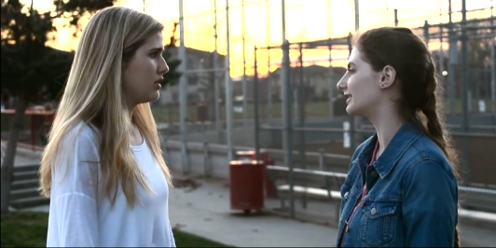
The Full Story (2016)
Butte County, Pleasant Valley High School
A story of a young adult with diagnosed depression that highlights the important message that a mental illness is just something you are dealing with and that it does not define your character.
View & Download

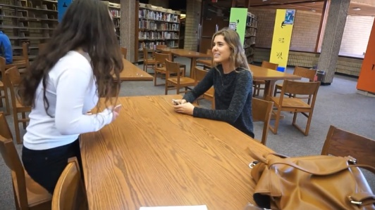
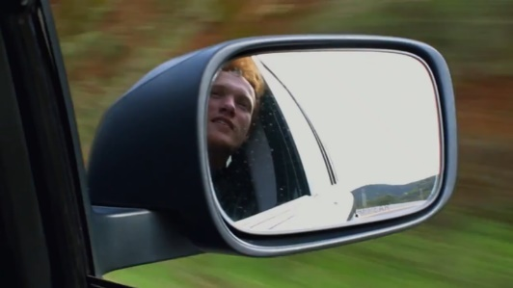
The Journey (2016)
Marin County, Redwood High School
A film that takes viewers on a road trip, showing the metaphorical journey of one youth’s experience in which he opens up to friends about his mental illness and receives support.
View & Download
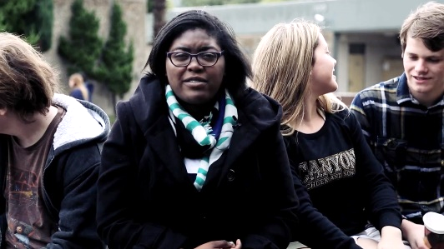
This Is Me (2015)
San Diego County, Torrye Pines High School
A student’s story about how life isn’t always what it looks like on social media and how opening up to friends about mental health challenges can be uplifting.
View & Download
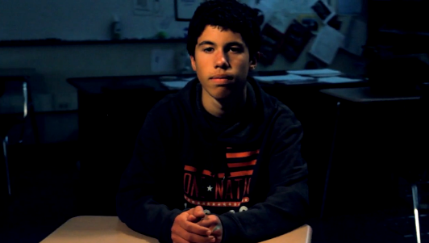
If We All Speak Loud Enough (2014)
Orange County, Canyon High School
When one friend begins showing warning signs for suicide, a friend notices and seeks the help of a school counselor.
View & Download
Circling Stigma (2013)
Marin County, Novato High School
This creatively shot film reminds youth that they are not alone in dealing with mental illness. Students in a support group discuss the stigma surrounding mental illness.
View & Download
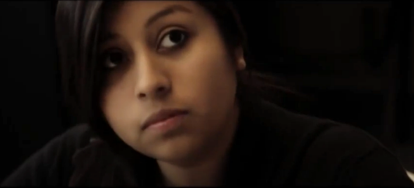
Emily’s Monster (2013)
Los Angeles County, California Virtual Academies
This film tells the story of a student diagnosed with Schizophrenia as she expresses her feelings through drawings of monsters in her art class. Her teacher disapproves of her art, but fellow classmates show her support and reassurance, highlighting the importance of standing up for those living with mental health challenges.
View & Download
More Than a Mental Illness (2013)
Sonoma County, Montgomery High School
A film that reminds youth that you are not defined by your mental illness and encourages standing up for those experiencing a mental health challenge.
View & Download

